**AM Lab: Additive Manufacturing Trends** (May 24, 2024, to July 29, 2024)

**Data Collection**

Over the past three months, AM Lab has utilized its cloud-based industry research tool, Sigma Engine, to monitor relevant events, news releases, and academic publications related to the Additive Manufacturing sector. While data collection is ongoing, the findings in this report cover the period from May 24, 2024, to July 29, 2024. The Sigma Engine, developed by AM Lab, employs a combination of web scraping and natural language modeling to identify, interpret, and store pertinent data concerning the latest developments in the additive manufacturing industry. Data is collected autonomously twice a day and integrated into Google Cloud Platform (GCP). Any nullified data has been excluded from this report.

**Mathematics and Data Analysis Methods**

The analysis used Term Frequency-Inverse Document Frequency (TF-IDF) to identify prominent terms in the dataset, followed by a frequency count of industry mentions related to additive manufacturing. The dataset, comprising academic papers, general articles, and scholarly articles, was filtered for industry-specific keywords. Weekly averages were calculated to smooth the data, making it easier to identify trends. The volatility of industry mentions was measured using standard deviation to identify consistent industries. Additionally, a total aggregation of mentions was conducted to assess the overall popularity of additive manufacturing across different sectors.

**Visualizations**

G1: Displays the total mentions of additive manufacturing across various industries, aggregated over the entire dataset period.

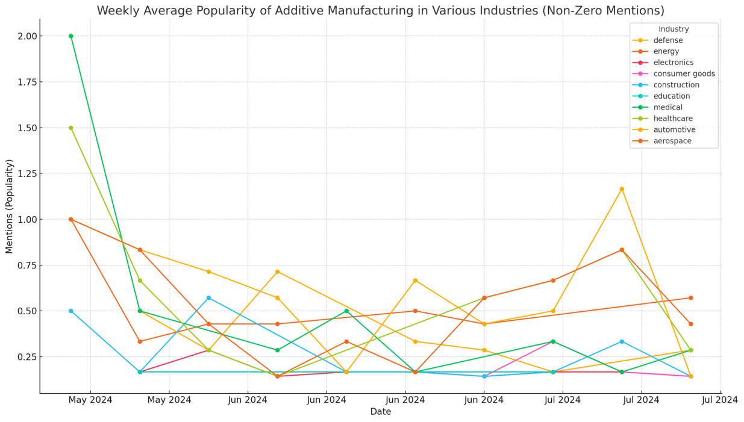

G2: Shows the weekly average popularity of additive manufacturing across various industries, based on the number of mentions. The x-axis represents time, marked by months, and the y-axis indicates the number of mentions.

G3: Highlights the industries with the most significant growth in mentions over time—defense, construction, and energy. The x-axis represents time, marked by months, and the y-axis indicates the number of mentions.

**Analysis and Commentary**

The data indicates a stable and growing interest in additive manufacturing across several industries, with electronics and consumer goods showing consistent mentions. This stability suggests these sectors have integrated additive manufacturing into their operations. The variability in other sectors, such as healthcare and aerospace, may reflect fluctuating investment or interest levels due to ongoing research and development efforts. The total mentions bar chart further clarifies which industries are most engaged with additive manufacturing, providing a broader context for understanding market dynamics.

**6-Month Market Predictions**

In the upcoming two quarters, Q3 and Q4, the additive manufacturing sector is projected to experience sustained growth, especially in the sectors that have shown the most significant increase in mentions: defense, construction, and energy. These industries are likely to drive demand for customized and complex components, utilizing additive manufacturing's capabilities for innovation and efficiency. The electronics and consumer goods sectors, although stable, are also expected to continue leveraging additive manufacturing technologies to enhance product offerings. The overall trend suggests a positive outlook for the sector, with potential for substantial developments in market penetration and technological advancements. This growth is anticipated to be supported by ongoing investments and advancements in material science and manufacturing processes, paving the way for broader adoption and application across various industries.  
  
**Future Reports**

Moving forward, AM Lab plans to publish reports of this nature on a weekly basis, providing timely and significant data analysis related to the additive manufacturing sector. As data collection continues daily through web scraping, the insights presented in these reports will become increasingly accurate, as the predictive capabilities of the Sigma Engine are enhanced by training on historical data. It should be noted that AM Lab's Sigma Engine is not limited to a single sector; it can be adapted to study and track other industries in a similar manner.